

**Program :**B.tech(CSE)

**Specialization :**AIML

**Course Title :**AI Assisted Coding

**Course Code :**24CS002PC215

**Semester :**3rd semester

**Academic Session :**2025-2026

**Name of Student :**Bachanagari Deekshitha

**Enrollment No. :**2403A52032

**Batch No. :**02

**Date :**26/08/2025

#LAB ASSIGNMENT

Task Description -1:

* Zero-shot: Prompt AI with only the instruction — Write a Python function to  
  generate the Fibonacci sequence up to n terms.

#PROMPT:

* Write a python function to generate the Fibonacci sequence up to n terms.

# QUESTION:

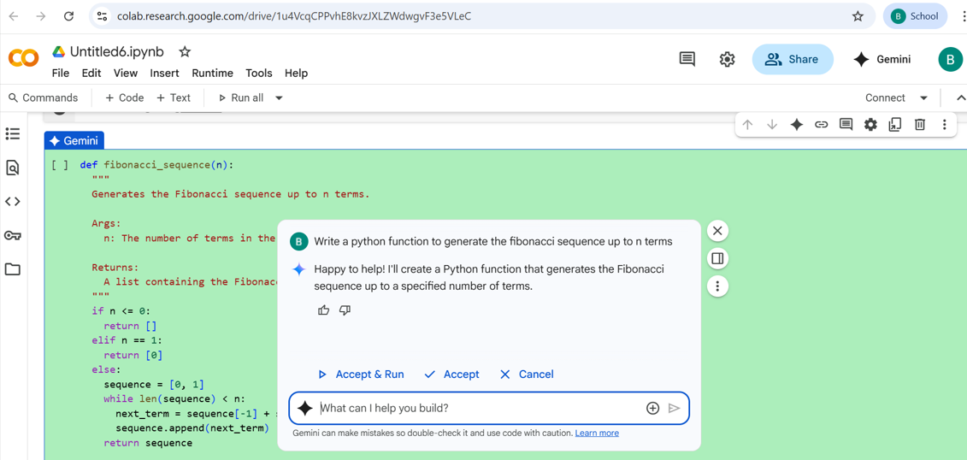

#CODE:

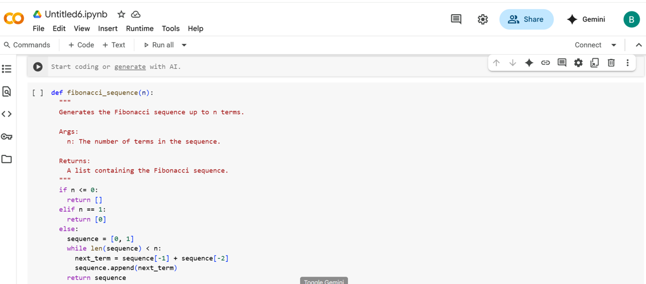

#OUTPUT:

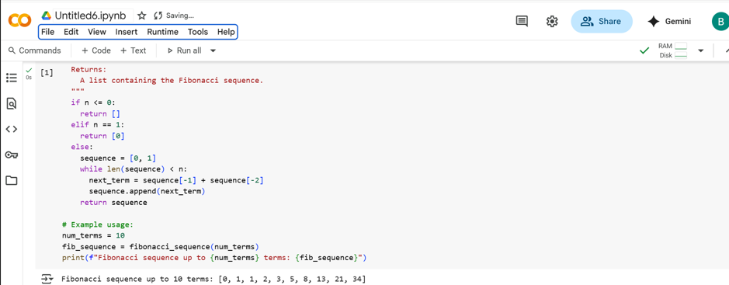

Task Description-2:

* One-shot: Provide one example: Input: 100, Output: 37.78 to help AI generate a  
  function that converts Fahrenheit to Celsius.

#PROMPT:

* Write a python function that converts Fahrenhit to Celsius with this example

#QUESTION:

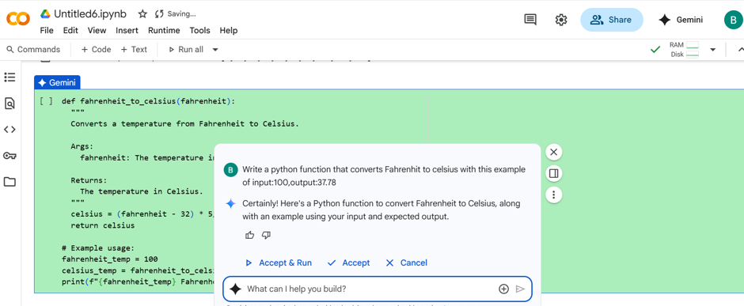

#CODE:

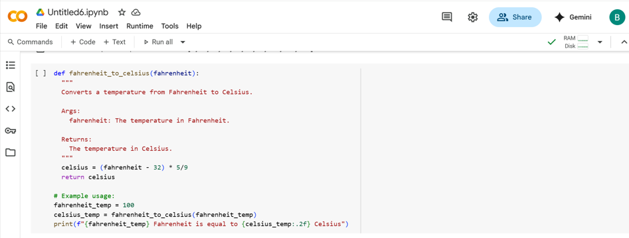

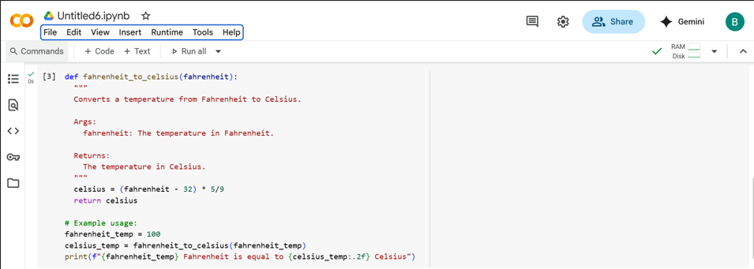

#OUTPUT:

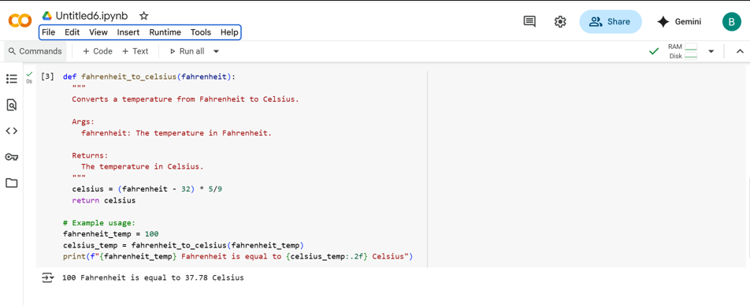

#Task Description:

* Few-shot: Give 2–3 examples to create a function that extracts the domain name from  
  an email address.

#PROMPT:

* Write a python function extract_domain(email) that returns the domain part of an email address,Give 2-3 eg. For the question.

#QUESTION:

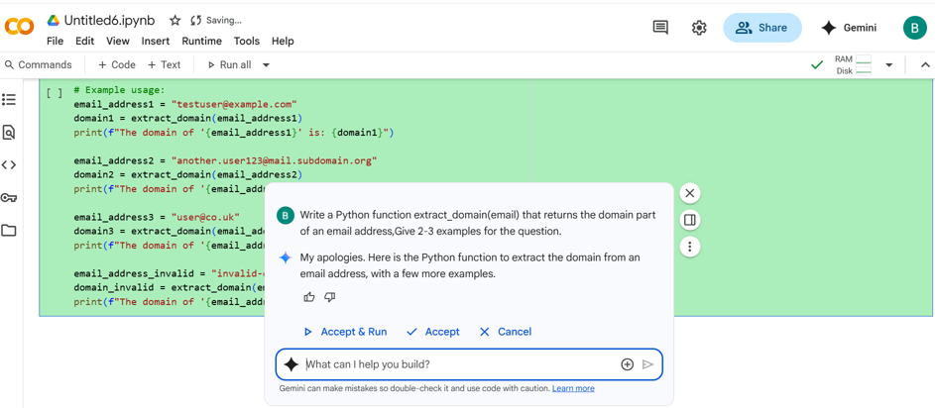

#CODE:

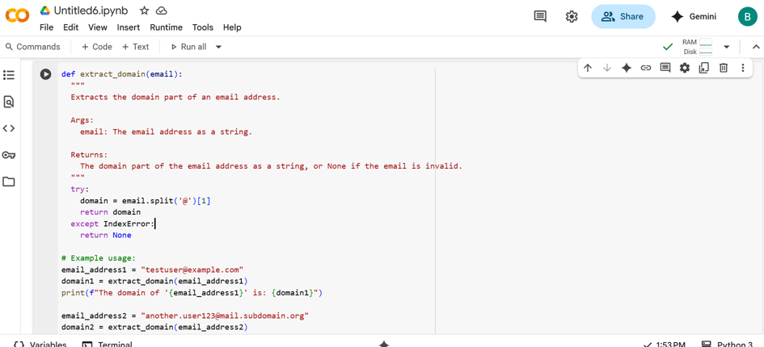

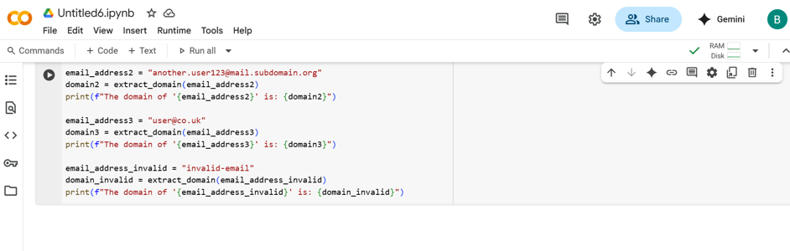

#OUTPUT:

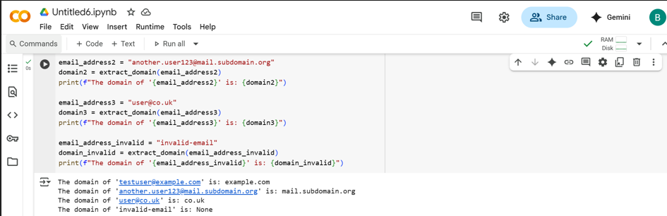

Task Description-3:

* Compare zero-shot vs few-shot prompting for generating a function that checks  
  whether a word is a palindrome, ignoring punctuation and case.

#PROMPT:

* Compare zero-shot and few-shot prompting for writing a python function that checks if a word is a palindrome,ignoring punctuation and case.show both outputs and explain how examples improve model accurancy.

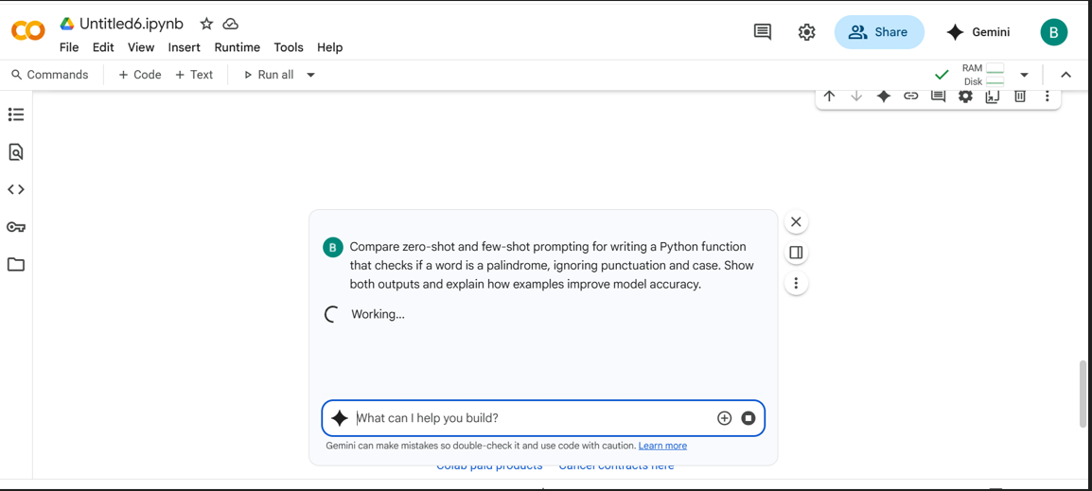

#CODE WITH OUTPUT:

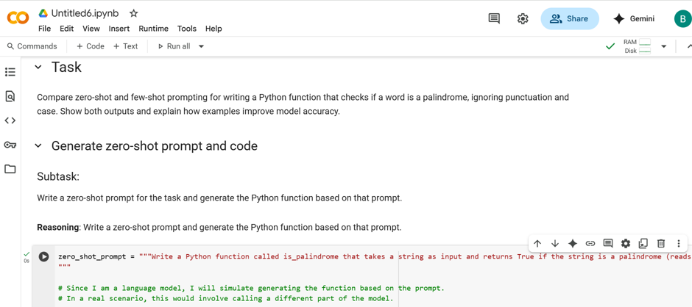

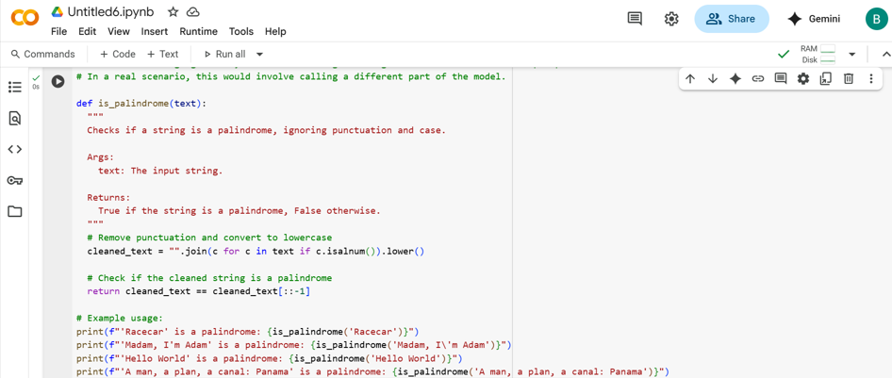

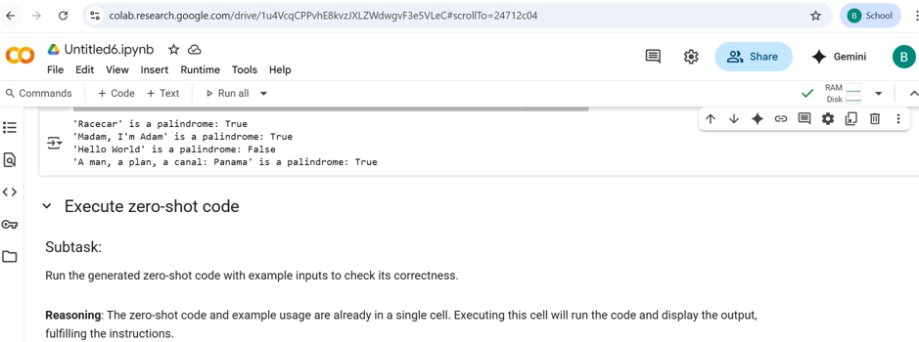

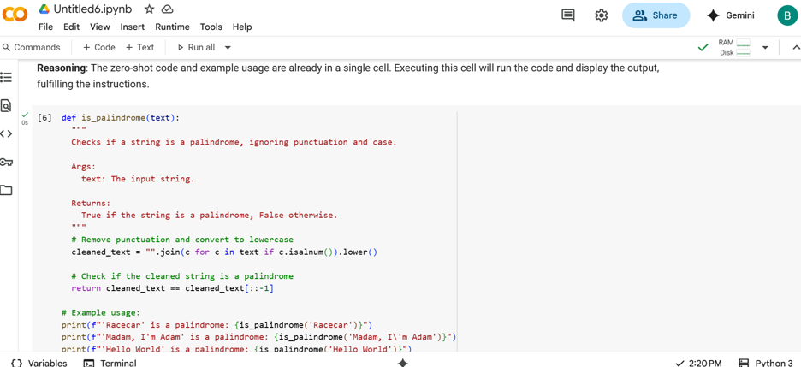

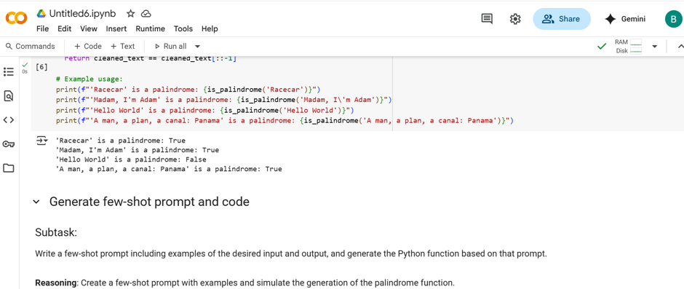

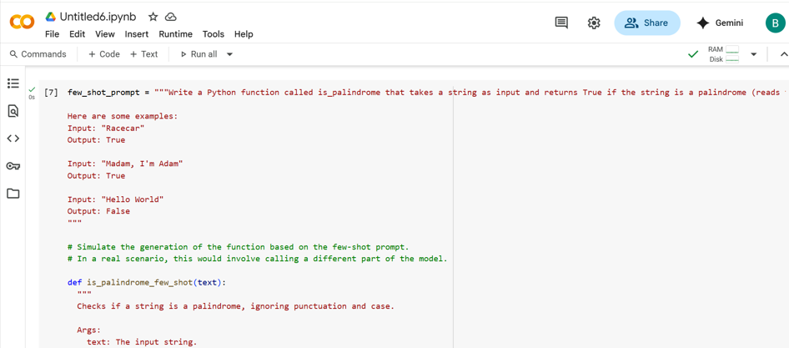

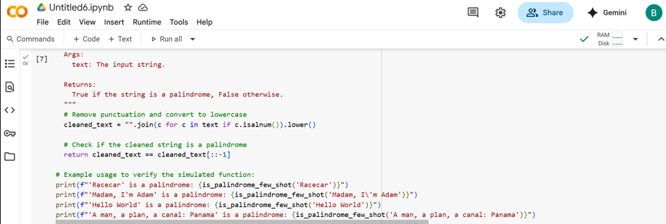

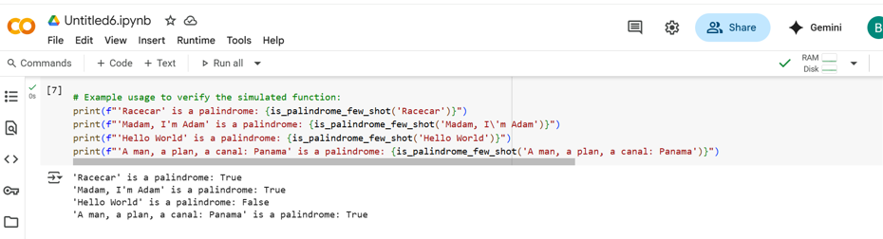

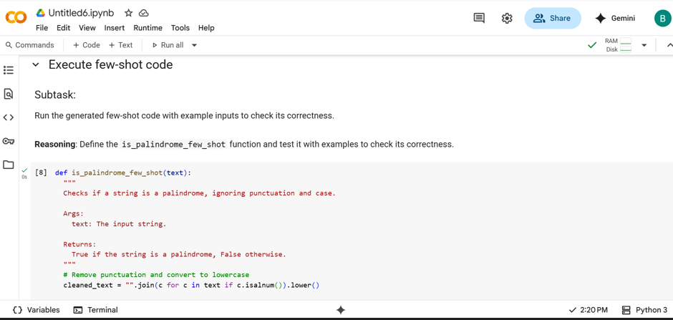

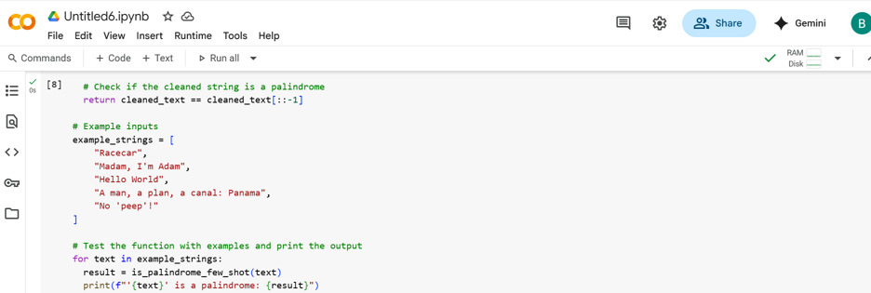

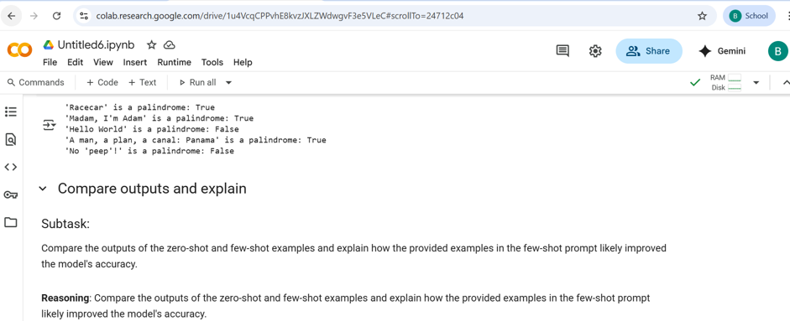

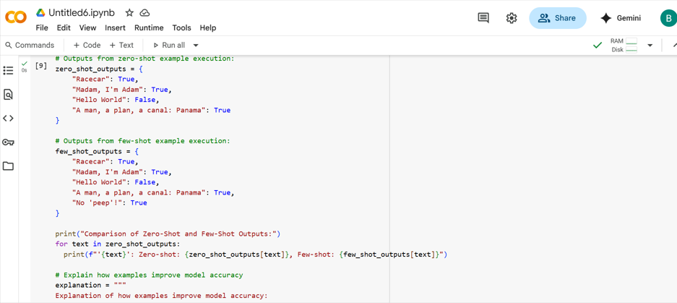

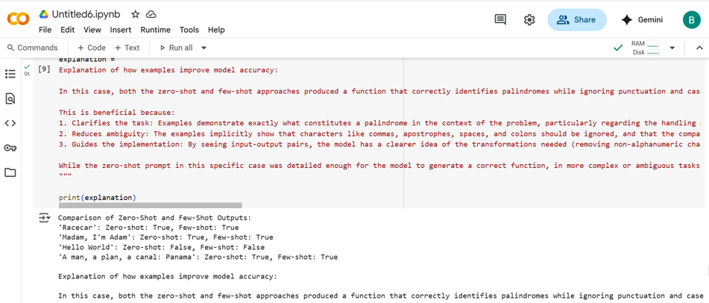

#SUMMERY:

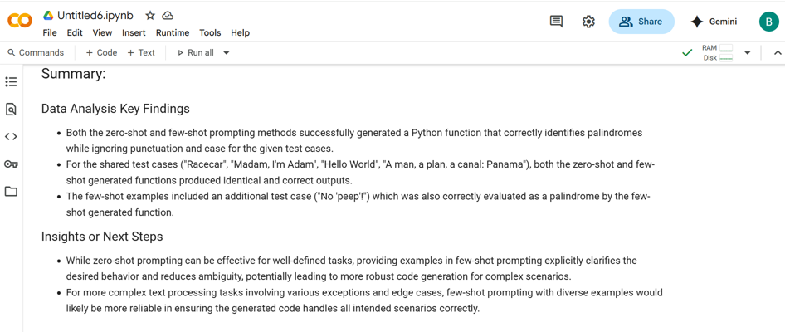

#Task Description-5:

* Use few-shot prompting with 3 sample inputs to generate a function that determines  
  the maximum of three numbers without using the built-in max() function.

#PROMPT:

* Write a python function find_max(a,b,c) that returns the largest of three numbers without using the built-in max() function. Using with this example find_max(10,25,15), find_max(-5,-10,-3), find_max(7,7,7).

#QUESTION:

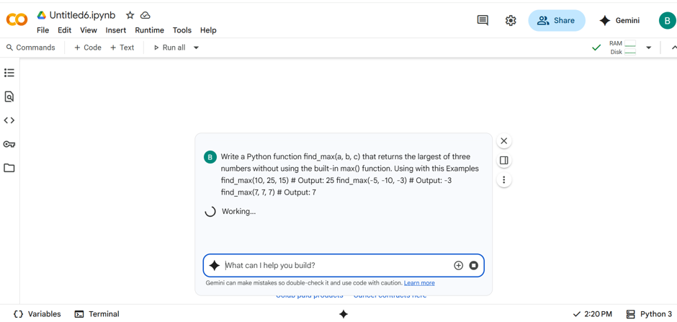

#CODE:

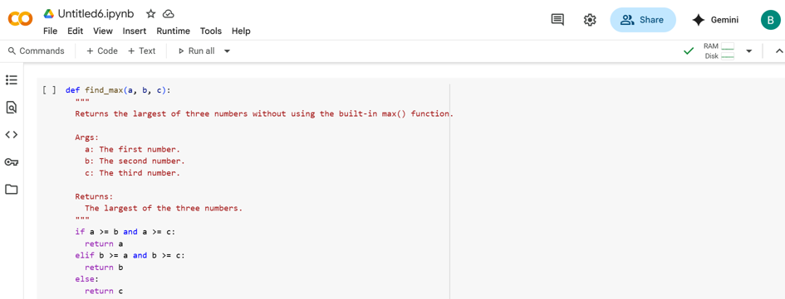

#OUTPUT:

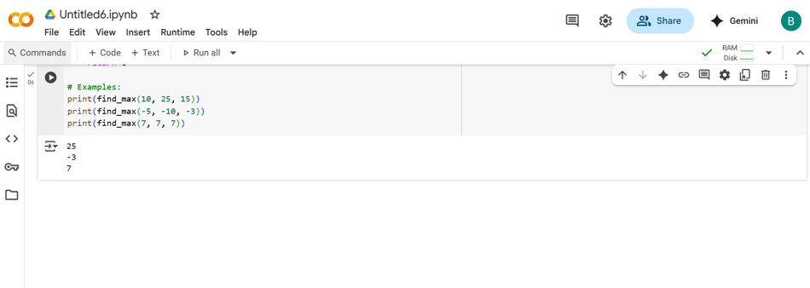

-THANK YOU-